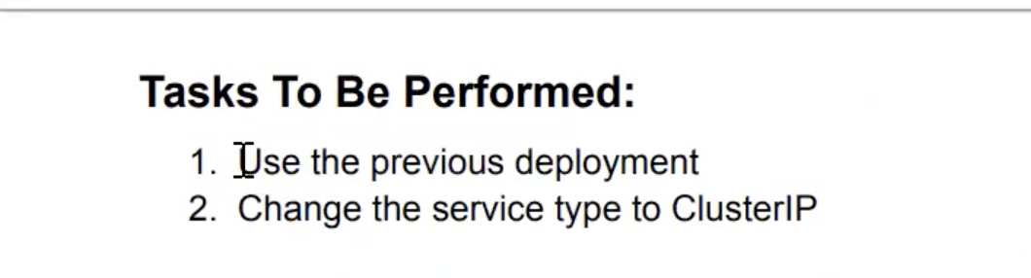

Create the Assignmnet4.yaml file and edit the changes as assignment 2 yaml file

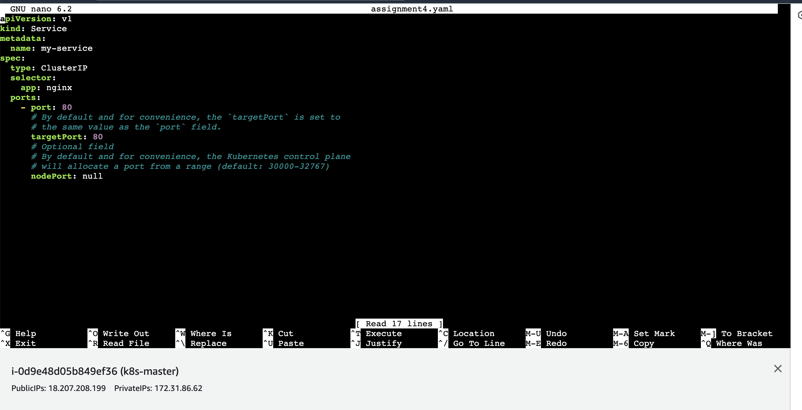

Run the command

kubectl apply -f assignment4.yaml

root@ip-172-31-86-62:/home/ubuntu# kubectl apply -f assignment4.yaml

service/my-service configured

run the below command

root@ip-172-31-86-62:/home/ubuntu# kubectl get svc

NAME TYPE CLUSTER-IP EXTERNAL-IP PORT(S) AGE

kubernetes ClusterIP 10.96.0.1 <none> 443/TCP 3h32m

my-service ClusterIP 10.97.24.234 <none> 80/TCP 73m

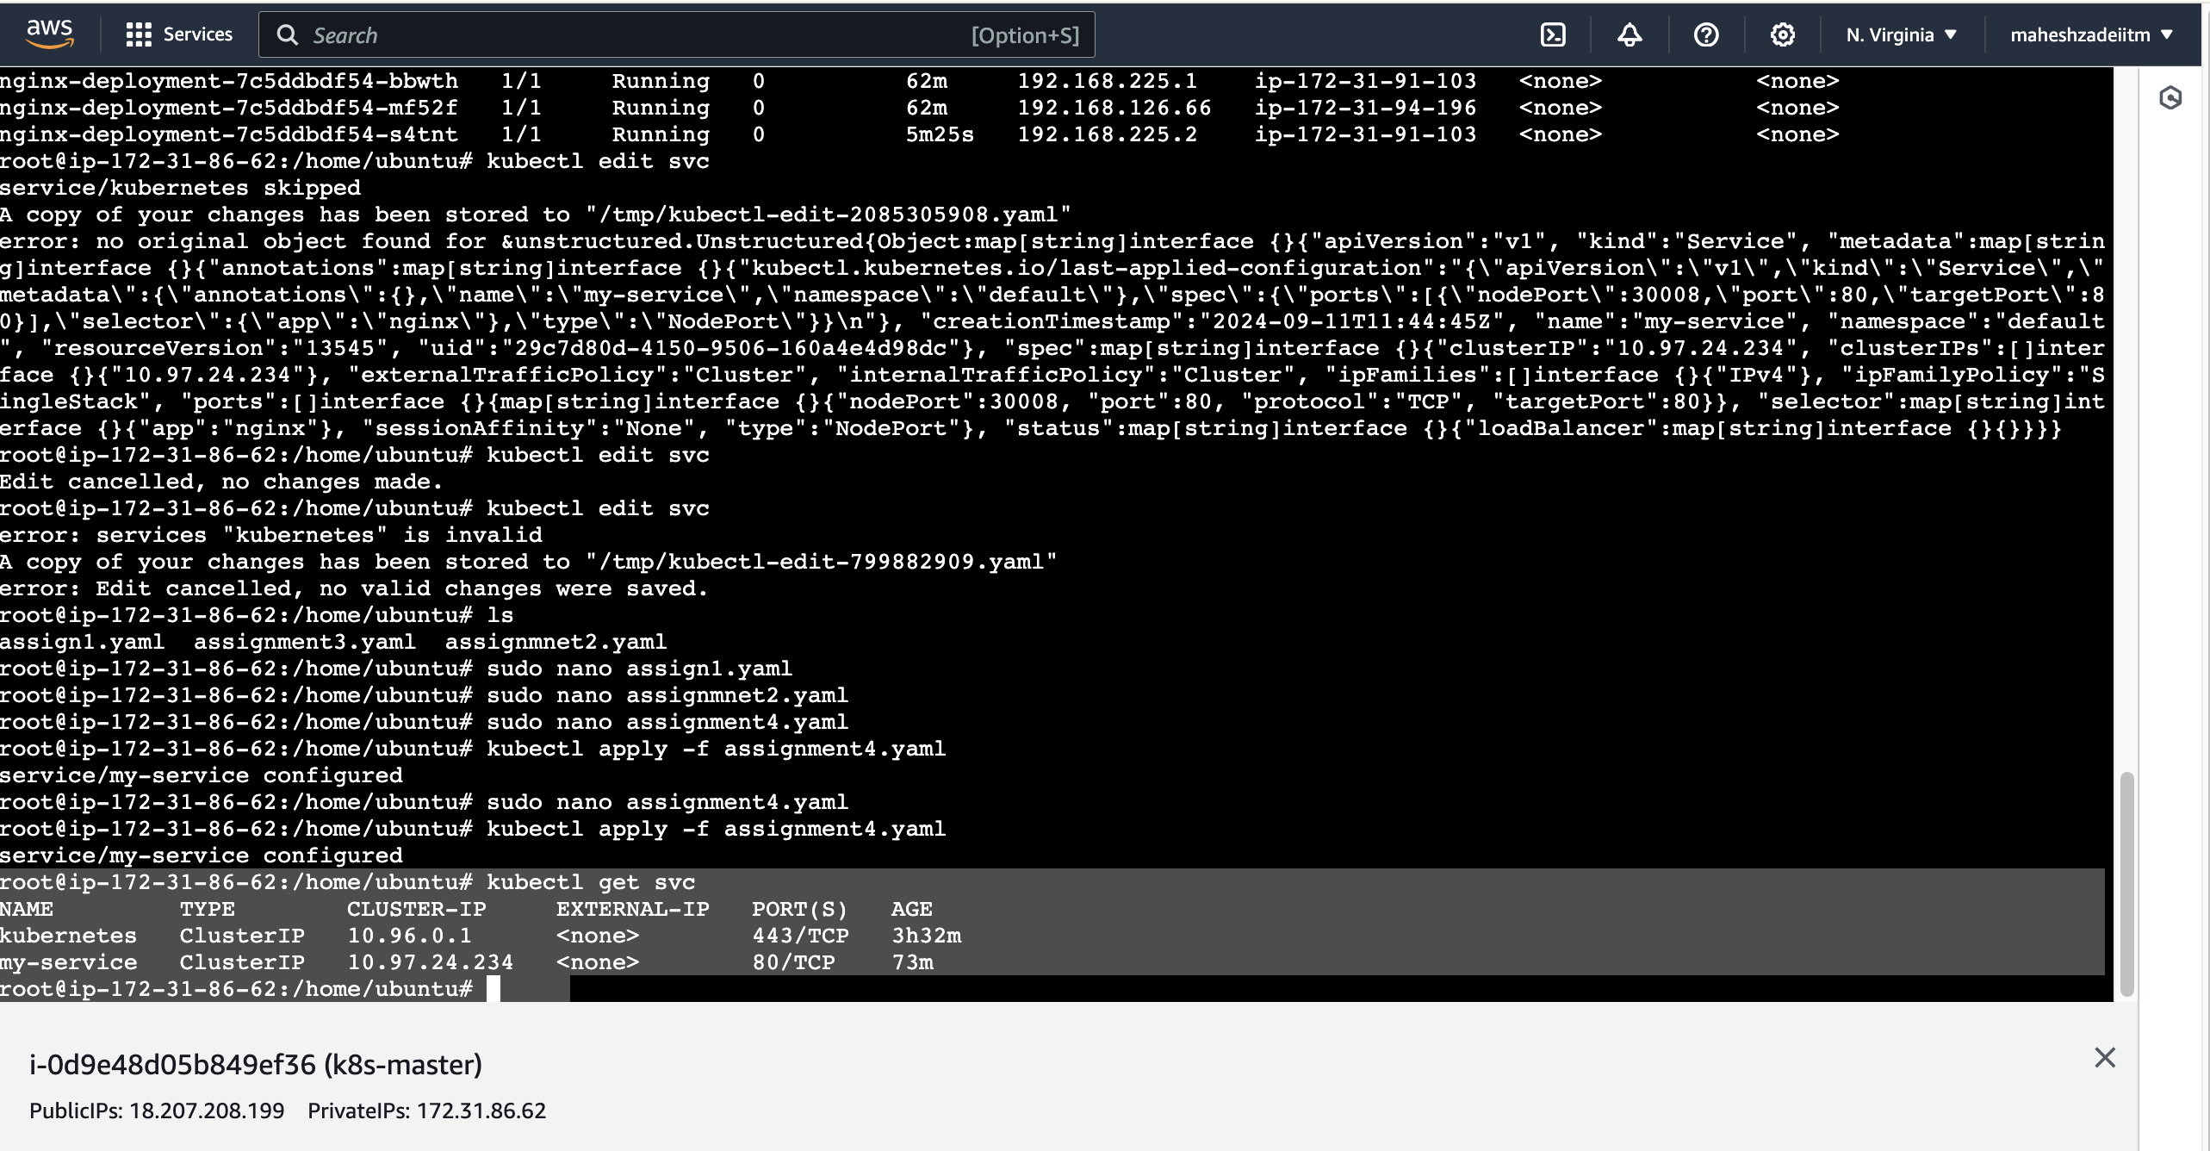

Assignment 4 is completed successfully.

Thanks